EXPERIMENT-2.3

Aim
To implement an interactive SVG drawing tool using mouse event handlers (mousedown, mousemove, mouseup) that allows users to draw shapes dynamically on an SVG canvas.
Theory
- SVG (Scalable Vector Graphics):
A markup language for creating vector-based graphics. Shapes (rectangles, circles, lines, paths) are drawn using tags like <rect>, <circle>, <line>, <path>.
- Mouse Events in JavaScript:
  - mousedown: Captures the starting point.
  - mousemove: Updates dimensions/coordinates dynamically.
  - mouseup: Finalizes the shape and stops drawing.
- Working Principle:
When the user presses the mouse (mousedown) on the SVG canvas, the starting coordinates are stored. As the mouse moves (mousemove), the dimensions of a temporary shape update. Releasing the mouse (mouseup) fixes the final shape.
This mechanism simulates how paint/drawing applications work, providing a real-world use of event-driven programming.

Procedure
- Create an HTML file with an SVG container for drawing.
- Apply CSS to style the canvas (e.g., borders).
- Write JavaScript to:
  - Detect when the mouse is pressed inside the SVG.
  - Draw shapes (e.g., rectangles) starting from that point.
  - Dynamically adjust shape size as the mouse moves.
  - Finalize the shape once the mouse button is released.
- Test by drawing multiple shapes interactively.

Code Implementation
<!DOCTYPE html>
<html lang="en">
<head>
<meta charset="UTF-8">
<title>SVG Drawing Tool</title>
<style>
body {
font-family: Arial, sans-serif;
text-align: center;
}
svg {
border: 2px solid #333;
background: #f9f9f9;
cursor: crosshair;
}
</style>
</head>
<body>
<h2>Interactive SVG Drawing Tool</h2>
<svg id="drawingArea" width="600" height="400"></svg>

<script>
const svg = document.getElementById("drawingArea");
let rect, startX, startY, isDrawing = false;

svg.addEventListener("mousedown", (e) => {
isDrawing = true;
startX = e.offsetX;
startY = e.offsetY;

rect = document.createElementNS("http://www.w3.org/2000/svg", "rect");
rect.setAttribute("x", startX);
rect.setAttribute("y", startY);
rect.setAttribute("width", 0);
rect.setAttribute("height", 0);
rect.setAttribute("fill", "rgba(0,150,255,0.3)");
rect.setAttribute("stroke", "blue");
rect.setAttribute("stroke-width", 2);

svg.appendChild(rect);
});

svg.addEventListener("mousemove", (e) => {
if (!isDrawing) return;

let currentX = e.offsetX;
let currentY = e.offsetY;

let width = currentX - startX;
let height = currentY - startY;

rect.setAttribute("width", Math.abs(width));
rect.setAttribute("height", Math.abs(height));
rect.setAttribute("x", Math.min(startX, currentX));
rect.setAttribute("y", Math.min(startY, currentY));
});

svg.addEventListener("mouseup", () => {
isDrawing = false;
});
</script>
</body>
</html>
OUTPUT:
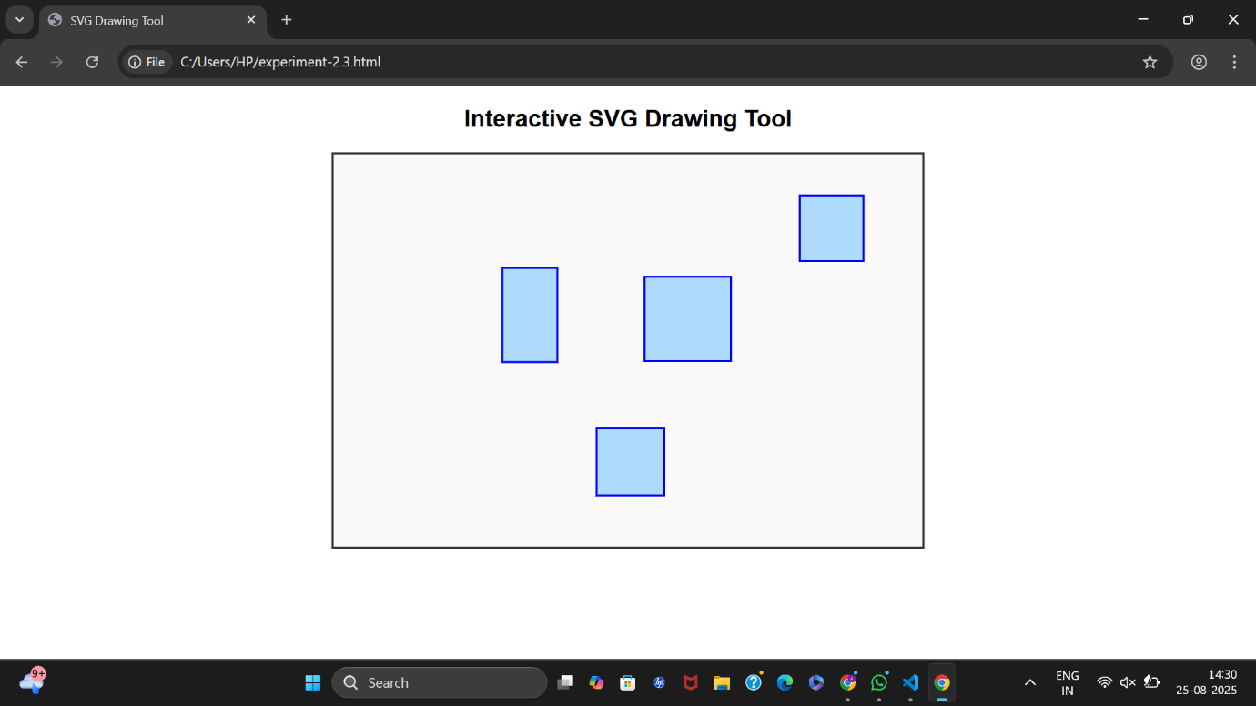

Outcomes
- Successfully created an interactive SVG canvas where users can draw rectangles using mouse actions.
- Learned how mouse event handlers (mousedown, mousemove, mouseup) work in synchronization.
- Demonstrated real-time updates to SVG elements using JavaScript.
- Can be extended to support different shapes, colors, erasers, and saving drawings.

